Token Budged Orchestration Strategies for Web Agents
Student Name: Thomas Beard | 220008104
Supervisor: Eduardo Alonso | Meeting Schedule: TBD

Contents
1 Introduction 2
2 Literature Review 3
2.1 The Web Agent Setting: WebArena as Benchmark 3
2.2 Multi-Agent Collaboration and the Fixed Pipeline (Strategy B) 3
2.3 Token Cost as a Structural Barrier 4
2.4 Budget-Aware Orchestration (Strategy C) 4
2.5 Evaluation Methodology in Agent Research 4
3 Methodology 4
4 Timeline 4
5 Risks 5
6 References 6
Appendix A – Figures & Tables 7
Appendix B – Research Ethics Review Form 9

1 Introduction
Large Language Model (LLM) agents are increasingly deployed to complete real world web tasks automatically such as filling forms, navigating e-commerce sites & querying databases and is a rapidly growing area of applied AI research (Zhou et al., 2023; Xu, F. et al. 2024). Multi-agent systems, in which several specialised LLM agents collaborate to complete a task, have demonstrated improved performance over single-agent approaches (Wang et al., 2024b). However, they introduce a critical practical constraint: token cost compounds with every agent call. As Chen et al (2026) documents, weekly token processing volume across major agent platforms grew nearly 68-fold between December 2024 and March 2026 (figure A.2), driven precisely by the iterative, multi-step nature of agentic workflows. In multi-agent settings specifically, deeper interaction chains trigger more LLM calls, lengthen inter-agent contexts, and add serialisation overhead which is structurally coupling performance to cost in ways that single agent evaluations do not capture (Cai, Ning and Liu, 2025).
However, most existing frameworks are designed to maximise accuracy under expanded or unrestricted compute budgets, and rarely incorporate mechanisms for budget control (Lu et al., 2026b). Without structured resource management, agents frequently exhaust token limits on redundant steps, with blindly allocating more resources often producing only marginal accuracy gains and diminishing returns (Lu et al., 2026b). The gap between the token cost incurred by multi-agent systems and the absence of principled mechanisms to control it is the central problem this project addresses.
This project addresses that gap through a controlled empirical comparison of three orchestration strategies: a single-agent baseline (Strategy A), a fixed multi-agent pipeline (Strategy B), and a dynamically routed multi-agent system using offline reinforcement learning (Strategy C). All three are evaluated under fixed global token budgets on WebArena (Zhou et al., 2023), a benchmark of 812 realistic web tasks across five self-hosted websites (figure A.1). The research question (table A.1) is whether dynamic, budget-aware token routing can match or exceed the task success of fixed pipelines while consuming fewer tokens and is a question with direct implications for the cost to viability of deploying web agents at scale.
The following objectives (which is further discussed in sections 3 & 4) will be completed by the project deadline:
- Implement and validate three orchestration strategies (A, B, and C) within the BrowserGym/WebArena environment, with a token accounting wrapper enforcing hard per-episode budget caps.
- Collect a labelled dataset of heuristic policy episodes across four token budget levels ({2,000; 4,000; 8,000; 16,000} tokens) to serve as training data for the Strategy C offline RL router.
- Train and evaluate a lightweight MLP router using offline reinforcement learning with entropy regularisation, comparing its routing behaviour against Strategies A and B at matched budgets.
- Produce empirical token performance curves and difficulty stratified breakdowns addressing all three research questions (table A.1).
- Submit dissertation, reporting all findings.
This project will produce four meaningful and concrete outputs: (1) A trained offline RL routing model (Strategy C); (2) An annotated dataset of agent episodes across budget conditions; (3) empirical cost performance curves and statistical comparisons across all three strategies.
The cost performance curves (3) are built from two primary per-episode measurements: task success rate (recorded as a binary label using WebArena’s built in evaluation scripts) and token consumption (recorded as total input + output tokens across all LLM calls within an episode). Furthermore, the accounted metrics will also follow: (i) Token efficiency (success rate / mean tokens consumed); (ii) cost curves plotting success rate against each budget level per strategy and finally (iii) difficulty stratified breakdowns disaggregating both metrics by WebArena’s Easy/Medium/Hard task tiers. And a cross-strategy comparison at matched budgets will use confidence intervals alongside probability values.
Regarding the four budget levels ({2,0000; 4,000; 8,000; 16,000} tokens per episode) is standard practice for producing evaluation points capable of revealing non-linear scaling behaviour and diminishing return thresholds (Lu et al., 2026b). So, for 2,000 tokens, this represents a constrained floor sufficient for simple tasks, whereas 16,000 tokens provide a comfortable ceiling for strategy A and remains meaningfully constrained for strategy B’s three agent pipeline.

2 Literature Review

2.1 The Web Agent Setting: WebArena as Benchmark
LLM agents that autonomously complete web tasks have advanced rapidly, but evaluation has lagged. Early benchmarks used simplified environments that did not reflect real web complexity (Shi et al., 2017). WebArena (Zhou et al., 2023) addresses this with 812 tasks across five self-hosted websites, evaluated programmatically against functional success conditions (figure 1). Its key value for this project is reproducibility as the Docker based environment eliminates the confounding variability of live websites, ensuring differences in success rate are attributable to orchestration design rather than environmental drift. Even GPT-4 achieved only 14.41% success, confirming WebArena as a genuine challenge space where architectural differences between strategies produce measurable outcomes.

2.2 Multi-Agent Collaboration and the Fixed Pipeline (Strategy B)
Multi-agent systems improve on single-agent performance by decomposing tasks across specialised roles. Wang et al., (2024b) formalises this in the Mixture of Agents (MoA) architecture, where each agent at layer i conditions on all outputs from layer i-1:
[1] A{i,j} = LLM(prompt, {A{i-1,1}, ..., A{i-1,k}})
[1] A{i,j} is a specific agent, so A{2,1} means "the first agent in the second layer." {A{i-1,1}, ..., A{i-1,k}} is the set of outputs from all agents in the previous layer. So before generating its response, each agent is shown everything the agents before it produced. MoA achieved state of the art performance on AlpacaEval 2.0 (65.1%), surpassing GPT-4 Omni using only open-source models. Strategy B operationalises MoA's layered principle as a fixed sequential pipeline: Planner Executor Critic. CodeAgents (Yang et al., 2025b) further motivates structured decomposition, demonstrating 55–87% input token reductions through codified planning. However, the critical limitation of any fixed pipeline is budget-blindness: all three agents are invoked every step regardless of task complexity or remaining budget, costing approximately 3–4x the tokens of a single-agent step (figure A.3).

2.3 Token Cost as a Structural Barrier
The token cost problem in multi-agent systems is a structural barrier to deployment at scale. As mentioned in the introduction section, Chen et al (2026) documents that that weekly token processing volume across major agent platforms grew 68-fold between December 2024 and March 2026, driven by coordination overhead in multi-agent workflows. Salim & Khatoonabadi (2026c) provide empirical grounding finding that iterative agent collaboration stages account for most of the token usage, with input tokens (accumulated from prior agent outputs passed as context) resulting in 53.9% of total consumption. Zhang et al., (2024b) further demonstrated that a significant fraction of inter-agent communication is redundant, so removing non-essential messages achieved 28–73% token reduction with no meaningful accuracy loss across six benchmarks.

2.4 Budget-Aware Orchestration (Strategy C)
BAMAS (Yang et al., 2025c) is the most directly related prior work, framing multi-agent construction as a constrained optimisation problem and using an RL policy to select collaboration topologies under budget constraints. It demonstrated up to 86% cost reduction at comparable performance. This project extends BAMAS Algorithm 1 from per-task topology selection to per-step routing decisions (choosing from {Planner, Executor, Critic, Stop} at each action step) conditioned on remaining budget, step count and task difficulty. The router is a lightweight MLP trained using offline RL with the objective:
[2] J(π) = 𝔼_π [R(τ)] + α · H(π)
[2] J(π) is the overall score the router is trying to maximise. 𝔼_π [R(τ)] is the expected reward the router receives by following its current policy (π) across episodes (τ). A high reward means the episode succeeded cheapy, and a low reward means it failed or was token expensive. α · H(π) is the entropy where (H) measures how varied the routers decisions are (i.e. a router that always picks “Executor” has low entropy, whereas one that spreads decisions across the different agents has high entropy). The coefficient (α) controls how much this bonus is weighted. This means the router is also rewarded for maintaining decisional variety.

2.5 Evaluation Methodology in Agent Research
Most frameworks report accuracy without accounting for the cost at which that accuracy was achieved (Mohammadi et al., 2025d). The token efficiency metric used in this project follows the cost of pass framing introduced by Wang et al. (2024c), which quantifies performance per unit of compute.

3 Methodology

3.1 Experimental Design
This study employs a controlled quantitative design in which three independent variables are systematically varied: strategy type (A, B, C), token budget ({2,000; 4,000; 8,000; 16,000} tokens per episode), and task difficulty (Easy/Medium/Hard). All three strategies are evaluated on the same WebArena tasks using the same underlying model (GPT-4o-mini) within the BrowserGym environment, ensuring that differences in measured outcomes are attributable to orchestration design rather than confounding factors. The primary dependent variables are task success rate and token consumption per episode, from which three derived metrics are computed: token efficiency (η = SR / μ(T)), cost curves, and difficulty-stratified breakdowns.

3.2 Strategy Implementations
All three strategies share a common token-accounting wrapper that intercepts every LLM API call, records input and output tokens, and enforces a hard per-episode budget cap by terminating the episode when the cumulative token count reaches the assigned budget level. This ensures budget enforcement is uniform and strategy-agnostic.
Strategy A implements a single GPT-4o-mini agent following the baseline framework from WebArena (Zhou et al., 2023). The agent receives the task prompt and web observation at each step, produces an action, and the budget is decremented accordingly, establishing the cost-performance floor.
Strategy B implements the fixed Planner → Executor → Critic pipeline (Figure A.3), grounded in the MoA architecture (Wang et al., 2024b). At each step, the Planner receives the task and current observation and produces a structured plan; the Executor receives the plan and produces an action; the Critic evaluates the action. Each agent receives all prior outputs as context, following equation [1]: Aᵢ,ⱼ = LLM(prompt, {Aᵢ₋₁,₁, ..., Aᵢ₋₁,ₖ}). The token budget is checked after the Critic each step; if exhausted, the episode terminates. This incurs 3–4× the per-step token cost of Strategy A.
Strategy C implements the MLP router trained using offline RL. At each step, the router receives a feature vector comprising: task embedding, remaining token budget (B), step count, episode progress flag, and difficulty tier. It outputs a routing decision from {Planner, Executor, Critic, Stop}, invoking only the selected agent for that step. The router is trained to maximise the objective from equation [2]: J(π) = 𝔼π[R(τ)] + α · H(π), where R(τ) encodes both task success and token cost, and the entropy term prevents collapse to a single routing strategy. The Stop action allows the router to conserve budget when continued steps are unlikely to yield success.

3.3 Data Collection and Router Training
Training data for the Strategy C router is collected by running Strategies A and B across all four budget levels on a representative subset of WebArena tasks, generating labelled episode trajectories. Each trajectory step is recorded as a (feature vector, action taken, outcome) tuple. The offline RL MLP is then trained on this dataset using policy gradient with entropy regularisation. The router is fixed after training and is not updated during evaluation, ensuring a fair comparison at matched budgets.

3.4 Analysis
Per-episode measurements (binary success label, total tokens consumed) are aggregated to compute: (i) success rate per condition; (ii) token efficiency η = SR / μ(T); (iii) cost curves plotting success rate against budget level for each strategy; and (iv) difficulty-stratified breakdowns by WebArena’s Easy/Medium/Hard task tiers. Cross-strategy comparisons at matched budget levels use bootstrap confidence intervals (10,000 resamples) given the binary nature of the success metric, with effect sizes reported alongside probability values. A key methodological limitation is distributional shift in the offline RL training data: the router is trained on episodes generated by Strategies A and B, which may not cover the full range of states encountered during evaluation. This is a known challenge in offline RL (Yang et al., 2025c) and is mitigated by the entropy regularisation term.

3.5 Ethics
This project raises no ethical concerns. All research involves automated software agents interacting with a sandboxed, self-hosted benchmark environment. No human participants, personal data, deception, or sensitive materials are involved. The CSREC Ethics Review Form has been completed and is included as Appendix B, with all questions answered No, confirming that no ethical approval is required.

4 Timeline
The Gantt chart below outlines all project phases from June to September 2025, with key dependencies and milestones identified. Strategy C’s RL router cannot be trained until the heuristic episode dataset is collected (M2), and full experiments cannot begin until the router is trained and validated (M3). Dissertation writing runs in parallel throughout, with a dedicated review period in the final two weeks before the personal deadline of 15 September 2025.
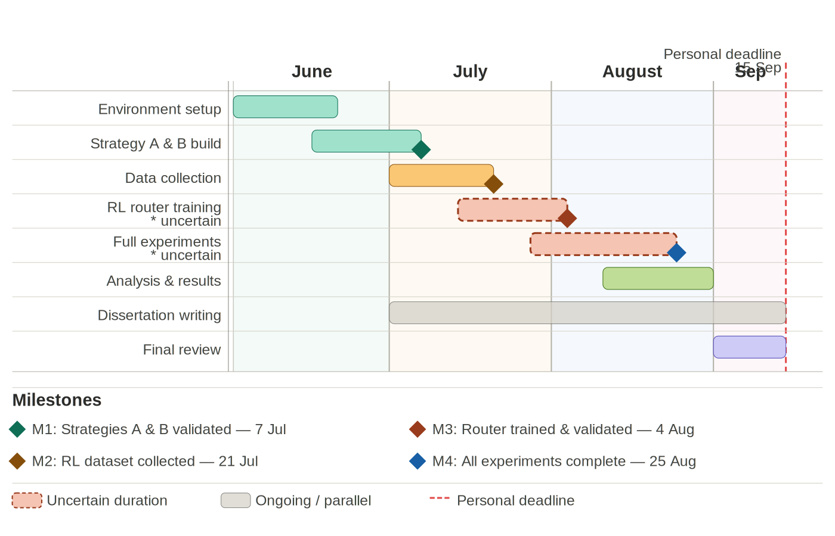
Figure 4: Project work plan — Token-Budgeted Orchestration Strategies for Web Agents

5 Risks
As this project involves no human participants (confirmed by the CSREC Ethics Review Form, Appendix B), risks to third parties are minimal. The register below covers technical, research, infrastructure, and project management risks. Likelihood and impact are rated High / Medium / Low and shaded accordingly.
# | Risk | Type | Likelihood | Impact | Mitigation | Recovery
R1 | Time overrun on uncertain phases (RL training, full experiments) | Project mgmt | High | High | Buffer weeks allocated in timeline (Fig. 4). Modular implementation allows partial completion. Uncertain tasks flagged early and prioritised. | Reduce scope — fewer budget levels or subset of WebArena tasks. Prioritise RQ1 and RQ2 over RQ3 if necessary.
R2 | API cost overrun — total spend exceeds $30-60 budget | Technical | Medium | High | Real-time token accounting wrapper tracks cumulative API spend. Pilot experiments on small task subset before full runs. Hard spend cap set in OpenAI dashboard. | Switch to cheaper model tier. Reduce episodes per condition. Use cached completions where available.
R3 | WebArena / BrowserGym environment instability or setup failure | Technical | Medium | High | Pin all Docker image and dependency versions. Run validation suite before full experiment runs. Environment setup allocated dedicated time in June. | Re-run affected episodes from checkpointed state. Escalate to BrowserGym GitHub issues. Revert to pinned stable release.
R4 | RL router fails to converge — policy collapses to single routing choice | Technical | Medium | High | Entropy regularisation (alpha in J(pi)) prevents premature convergence. Monitor training loss and routing diversity. Validate on held-out episode set. | Fall back to rule-based heuristic router. Report as limitation and still compare Strategy A vs B.
R5 | GPT-4o-mini API deprecation, pricing change, or rate limiting | Infrastructure | Low | High | Monitor OpenAI API changelog throughout project. Claude Haiku identified as equivalent-cost alternative. Prompts designed to be model-agnostic. | Switch model mid-project. Re-run pilot to verify comparable baseline performance before continuing.
R6 | Insufficient or low-quality training data for offline RL router | Research | Medium | Medium | Collect episodes across all 4 budget levels and difficulty tiers to maximise diversity. Record step-level features for richer router conditioning. | Reduce MLP router complexity to prevent overfitting. Apply data augmentation. Report data limitations explicitly.
R7 | Inconclusive results — no significant difference between strategies | Research | Low | Medium | Bootstrap CIs ensure statistical sensitivity. Effect sizes reported. Difficulty-stratified analysis may surface differences masked in aggregate results. | Report null result as valid empirical contribution. Broaden analysis to error profiles and failure modes.
R8 | Data or experiment log loss — results or model weights deleted/corrupted | Infrastructure | Low | High | Daily automated backups to GitHub and Google Drive. Checkpoint saves after every 50 episodes. Model weights versioned separately. | Restore from most recent checkpoint. Re-run only episodes completed after last backup.
R9 | Researcher unavailability due to illness or unforeseen circumstances | Project mgmt | Low | High | Personal deadline (15 Sep) provides 9-day buffer before submission (24 Sep). Regular supervisor meetings to flag early delays. | Communicate with supervisor immediately. Reprioritise to core objectives. University extenuating circumstances process available if required.
R10 | Reproducibility failure — results cannot be independently verified | Research | Low | Medium | All dependency versions pinned and documented. Random seeds fixed and recorded. Full environment specification published with dissertation code. | Re-run on pinned Docker environment before submission. Document any non-determinism explicitly in methodology.
Shading key: High = red (#FFD9D9) Medium = amber (#FFF3CD) Low = green (#D4EDDA)

6 References
Zhou et al., (2023) Zhou, S., Xu, F., Zhu, H., Zhou, X., Lo, R., Sridhar, A., Cheng, X., Bisk, Y., Fried, D., Alon, U. and Neubig, G. (n.d.). WebArena: A Realistic Web Environment for Building Autonomous Agents. [online] Available at: https://webarena.dev/static/paper.pdf
Xu, F. et al. (2024). TheAgentCompany: Benchmarking LLM Agents on Consequential Real World Tasks. arXiv:2412.14161 [online] Available at: https://arxiv.org/pdf/2412.14161
Wang et al., (2024b) Arxiv.org. (2022). Mixture-of-Agents Enhances Large Language Model Capabilities. [online] Available at: https://arxiv.org/html/2406.04692v1
Chen, Y., Chen, J., He, C., Li, Y., Ji, Y., Wu, Y., Yang, D., Diao, L., Shou, L., Zhang, H., Li, H. and Chen, G. (2026). Token Economics for LLM Agents: A Dual-View Study from Computing and Economics. [online] arXiv.org. Available at: https://arxiv.org/abs/2605.09104
Cai, S., Ning, Y. and Liu, H. (2025). AgentBalance: Backbone-then-Topology Design for Cost-Effective Multi-Agent Systems under Budget Constraints. arXiv:2512.11426 [online] arXiv.org. Available at: https://arxiv.org/abs/2512.11426
Li, Y., Deng, W., Li, J. and Li, X. (2026b). Spend Less, Reason Better: Budget-Aware Value Tree Search for LLM Agents. arXiv:2603.12634 [online] arXiv.org. Available at: https://arxiv.org/abs/2603.12634
‌Shi, T., Andrej Karpathy, Fan, L., Hernandez, J. and Liang, P. (2017). World of Bits: An Open-Domain Platform for Web-Based Agents. PMLR, [online] pp.3135–3144. Available at: https://proceedings.mlr.press/v70/shi17a.html
Yang, B., He, X., Gao, H., Cao, Y., Li, X. and Hsu, D. (2025b). CodeAgents: A Token-Efficient Framework for Codified Multi-Agent Reasoning in LLMs. [online] arXiv.org. Available at: https://arxiv.org/abs/2507.03254
Salim, M., Latendresse, J., Khatoonabadi, S. and Shihab, E. (2026c). Tokenomics: Quantifying Where Tokens Are Used in Agentic Software Engineering. [online] arXiv.org. Available at: https://arxiv.org/abs/2601.14470
Zhang, G., Yue, Y., Li, Z., Yun, S., Wan, G., Wang, K., Cheng, D., Yu, J.X. and Chen, T. (2024b). Cut the Crap: An Economical Communication Pipeline for LLM-based Multi-Agent Systems. [online] arXiv.org. Available at: https://arxiv.org/abs/2410.02506.
Yang, L., Luo, J., Liu, X., Lou, Y. and Chen, Z. (2025c). BAMAS: Structuring Budget-Aware Multi-Agent Systems. [online] arXiv.org. Available at: https://arxiv.org/abs/2511.21572
Mohammadi, M., Li, Y., Lo, J. and Yip, W. (2025d). Evaluation and Benchmarking of LLM Agents: A Survey. pp.6129–6139. Available at: https://doi.org/10.1145/3711896.3736570
Wang, J., Jain, S., Zhang, D., Ray, B., Kumar, V. and Athiwaratkun, B. (2024c). Reasoning in Token Economies: Budget-Aware Evaluation of LLM Reasoning Strategies. [online] arXiv.org. Available at: https://arxiv.org/abs/2406.06461

Appendix A – Figures & Tables
Figure 1: (Zhou et al., 2023) WebArena Structure
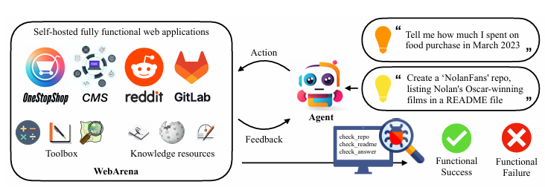

Figure 2: (Chen et al., 2026) Token Usage 2024 - 2026
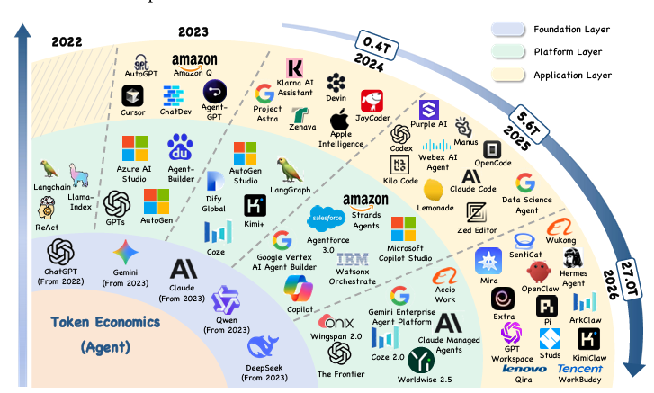
Table 1: Research Questions
No. | Research Question
RQ1 | How does task success rate, token efficiency and error profile vary as a function of a fixed global token budget when comparing the 3 orchestration strategies on WebArena?
RQ2 | How do the three strategies differ in sensitivity to task difficulty (Easy / Medium / Hard) in terms of success rate and failure modes across WebArena tasks?
RQ3 | Given the same global token budget, how do different intra-episode allocation schemes (front-loaded, even-distribution, reactive) affect success rate and token efficiency across all three strategies?

Figure 3: Strategies Architecture Diagram (Drawn on Draw.io)
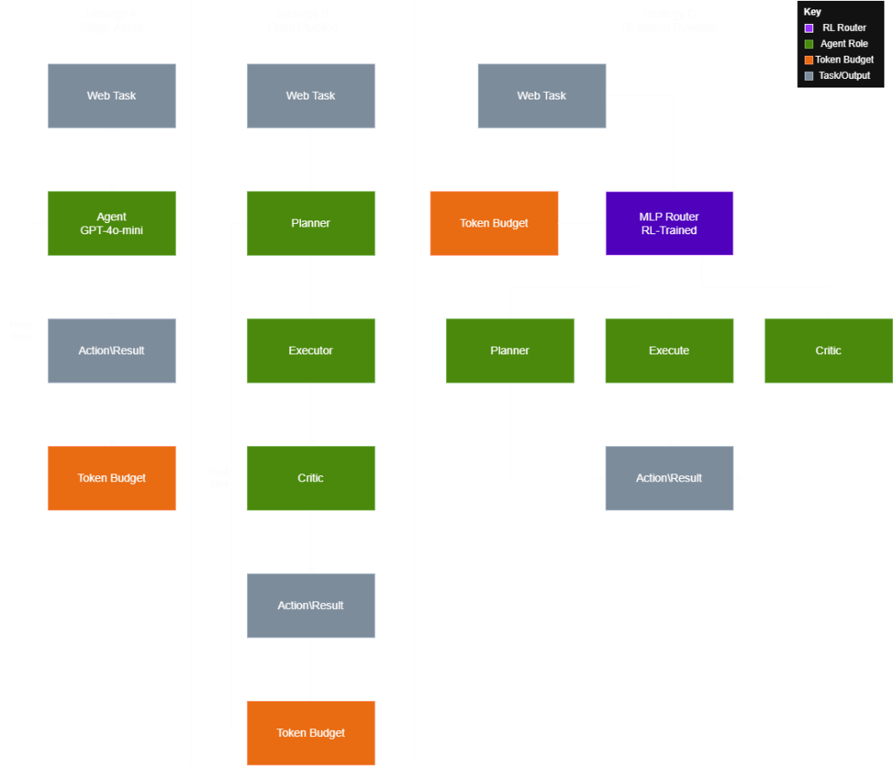

Appendix B – Research Ethics Review Form
Research Ethics Review Form: BSc, MSc and MA Projects
Computer Science Research Ethics Committee (CSREC)
http://www.city.ac.uk/department-computer-science/research-ethics
Undergraduate and postgraduate students undertaking their final project in the Department of Computer Science are required to consider the ethics of their project work and to ensure that it complies with research ethics guidelines. In some cases, a project will need approval from an ethics committee before it can proceed. Usually, but not always, this will be because the student is involving other people (“participants”) in the project.
In order to ensure that appropriate consideration is given to ethical issues, all students must complete this form and attach it to their project proposal document. There are two parts:
PART A: Ethics Checklist. All students must complete this part. The checklist identifies whether the project requires ethical approval and, if so, where to apply for approval.
PART B: Ethics Proportionate Review Form. Students who have answered “no” to all questions in A1, A2 and A3 and “yes” to question 4 in A4 in the ethics checklist must complete this part. The project supervisor has delegated authority to provide approval in such cases that are considered to involve MINIMAL risk. The approval may be provisional – identifying the planned research as likely to involve MINIMAL RISK. In such cases you must additionally seek full approval from the supervisor as the project progresses and details are established. Full approval must be acquired in writing, before beginning the planned research.

A.1 If you answer YES to any of the questions in this block, you must apply to an appropriate external ethics committee for approval and log this approval as an External Application through Research Ethics Online - https://ethics.city.ac.uk/ |  | Delete as appropriate
1.1 | Does your research require approval from the National Research Ethics Service (NRES)?  e.g. because you are recruiting current NHS patients or staff?  If you are unsure try - https://www.hra.nhs.uk/approvals-amendments/what-approvals-do-i-need/ | NO
1.2 | Will you recruit participants who fall under the auspices of the Mental Capacity Act?  Such research needs to be approved by an external ethics committee such as NRES or the Social Care Research Ethics Committee - http://www.scie.org.uk/research/ethics-committee/ | NO
1.3 | Will you recruit any participants who are currently under the auspices of the Criminal Justice System, for example, but not limited to, people on remand, prisoners and those on probation?  Such research needs to be authorised by the ethics approval system of the National Offender Management Service. | NO
A.2 If you answer YES to any of the questions in this block, then unless you are applying to an external ethics committee, you must apply for approval from the Senate Research Ethics Committee (SREC) through Research Ethics Online -  https://ethics.city.ac.uk/ |  | Delete as appropriate
2.1 | Does your research involve participants who are unable to give informed consent?  For example, but not limited to, people who may have a degree of learning disability or mental health problem, that means they are unable to make an informed decision on their own behalf. | NO
2.2 | Is there a risk that your research might lead to disclosures from participants concerning their involvement in illegal activities? | NO
2.3 | Is there a risk that obscene and or illegal material may need to be accessed for your research study (including online content and other material)? | NO

2.4 | Does your project involve participants disclosing information about special category or sensitive subjects?  For example, but not limited to: racial or ethnic origin; political opinions; religious beliefs; trade union membership; physical or mental health; sexual life; criminal offences and proceedings | NO
2.5 | Does your research involve you travelling to another country outside of the UK, where the Foreign & Commonwealth Office has issued a travel warning that affects the area in which you will study?  Please check the latest guidance from the FCO - http://www.fco.gov.uk/en/ | NO
2.6 | Does your research involve invasive or intrusive procedures?  These may include, but are not limited to, electrical stimulation, heat, cold or bruising. | NO
2.7 | Does your research involve animals? | NO
2.8 | Does your research involve the administration of drugs, placebos or other substances to study participants? | NO
A.3 If you answer YES to any of the questions in this block, then unless you are applying to an external ethics committee or the SREC, you must apply for approval from the Computer Science Research Ethics Committee (CSREC) through Research Ethics Online - https://ethics.city.ac.uk/  Depending on the level of risk associated with your application, it may be referred to the Senate Research Ethics Committee. |  | Delete as appropriate
3.1 | Does your research involve participants who are under the age of 18? | NO
3.2 | Does your research involve adults who are vulnerable because of their social, psychological or medical circumstances (vulnerable adults)?  This includes adults with cognitive and / or learning disabilities, adults with physical disabilities and older people. | NO
3.3 | Are participants recruited because they are staff or students of City, University of London?  For example, students studying on a particular course or module.  If yes, then approval is also required from the Head of Department or Programme Director. | NO
3.4 | Does your research involve intentional deception of participants? | NO
3.5 | Does your research involve participants taking part without their informed consent? | NO
3.5 | Is the risk posed to participants greater than that in normal working life? | NO
3.7 | Is the risk posed to you, the researcher(s), greater than that in normal working life? | NO
A.4 If you answer YES to the following question and your answers to all other questions in sections A1, A2 and A3 are NO, then your project is deemed to be of MINIMAL RISK.  If this is the case, then you can apply for approval through your supervisor under PROPORTIONATE REVIEW. You do so by completing PART B of this form.  If you have answered NO to all questions on this form, then your project does not require ethical approval. You should submit and retain this form as evidence of this. |  | Delete as appropriate
4 | Does your project involve human participants or their identifiable personal data?  For example, as interviewees, respondents to a survey or participants in testing. | NO

